Algeria

## Respect for rule of law (ROL) data

The data set shows the data on the respect of the rule of law for the country.

## # A tibble: 19 x 5  
## country iso3c date ruleOfLaw ruleOfLawCategory4   
## <chr> <chr> <dbl> <dbl> <chr>   
## 1 Algeria DZA 1996 -1.22 ROL highly disrespected   
## 2 Algeria DZA 1998 -1.16 ROL highly disrespected   
## 3 Algeria DZA 2000 -1.21 ROL highly disrespected   
## 4 Algeria DZA 2002 -0.630 ROL moderately disrespected  
## 5 Algeria DZA 2003 -0.588 ROL moderately disrespected  
## 6 Algeria DZA 2004 -0.621 ROL moderately disrespected  
## 7 Algeria DZA 2005 -0.751 ROL moderately disrespected  
## 8 Algeria DZA 2006 -0.709 ROL moderately disrespected  
## 9 Algeria DZA 2007 -0.773 ROL moderately disrespected  
## 10 Algeria DZA 2008 -0.741 ROL moderately disrespected  
## 11 Algeria DZA 2009 -0.794 ROL moderately disrespected  
## 12 Algeria DZA 2010 -0.785 ROL moderately disrespected  
## 13 Algeria DZA 2011 -0.808 ROL moderately disrespected  
## 14 Algeria DZA 2012 -0.772 ROL moderately disrespected  
## 15 Algeria DZA 2013 -0.689 ROL moderately disrespected  
## 16 Algeria DZA 2014 -0.773 ROL moderately disrespected  
## 17 Algeria DZA 2015 -0.869 ROL moderately disrespected  
## 18 Algeria DZA 2016 -0.862 ROL moderately disrespected  
## 19 Algeria DZA 2017 -0.865 ROL moderately disrespected

## Respect for rule of law (ROL) trend

The plot shows the trend of the respect for the rule of law for the country.

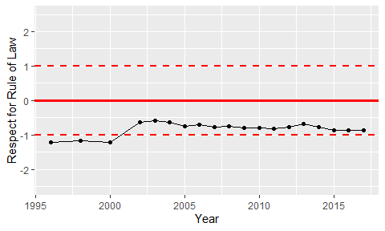

Trend of the Respect for the Rule of Law